Chapter 6, Solution 23.

Using Fig. 6.57, design a problem to help other students better understand how capacitors work together when connected in series and parallel.

Although there are many ways to work this problem, this is an example based on the same kind of problem asked in the third edition.

Problem

For the circuit in Fig. 6.57, determine:

- the voltage across each capacitor,
- the energy stored in each capacitor.

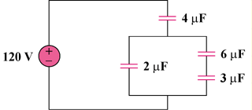

Figure 6.57

Solution

(a) 3μF is in series with 6μF 3x6/(9) = 2μF
v_{4μF} = 1/2 x 120 = 60V
v_{2μF} = 60V
v_{6μF} = 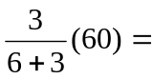20V
v_{3μF} = 60 - 20 = 40V

- Hence w = 1/2 Cv²
w_{4μF} = 1/2 x 4 x 10⁻⁶ x 3600 = 7.2mJ
w_{2μF} = 1/2 x 2 x 10⁻⁶ x 3600 = 3.6mJ
w_{6μF} = 1/2 x 6 x 10⁻⁶ x 400 = 1.2mJ
w_{3μF} = 1/2 x 3 x 10⁻⁶ x 1600 = 2.4mJ

